**NMAP SCANNING**

**Exp No:-1**

**Aim:**

To install and perform Nmap scan (note :- you may use ip address or website name)

**Procedure:**

Step 1: Open Nmap from Kali Linux (Goto Applications->select Information Gathering>select

Nmap)

Step 2: Perform different types of scan

(Tcp, Udp, Ack, Syn, Fin, Null, Xmas, Rpc, Idle)- scan types

Scanning Techniques

Flag Use Example

-sS TCP syn port scan nmap -sS 192.168.1.1

-sT TCP connect port scan nmap -sT 192.168.1.1

–sU UDP port scan nmap –sU 192.168.1.1

–sA TCP ack port scan nmap –sA 192.168.1.1

**Output:**

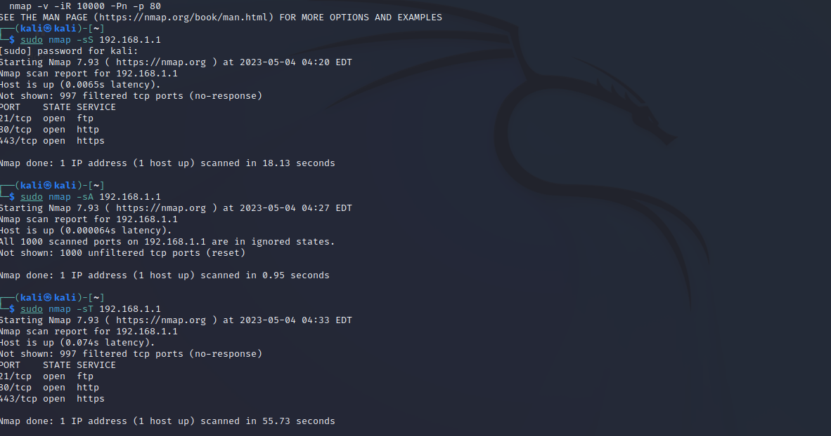

**Result:**

Hence the nmap scan performed successfully